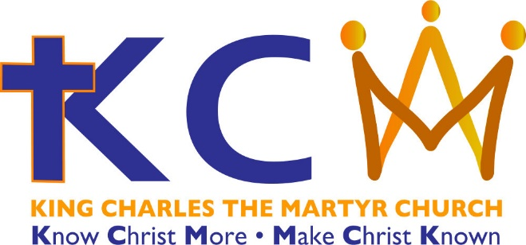

Christmas 2020
We hope that we will be able to welcome you to worship with us at KCM this Christmas. We will hold public worship in church ensuring that all Covid-19 guidelines are followed (not attending if you are unwell, signing in to enable test and trace, wearing face coverings and maintaining social distance between households and bubbles at all times).

All our services will be live streamed, so even if we cannot welcome you into the building you will be able to join in worship from home and will then available on our Facebook page to be watched at a later date.

Keep an eye on our social media for more information.
www.kcm-church.org.uk
01707 665579 office@kcm-church.org.uk

This Photo by Unknown Author is licensed under CC BY-SA  @KCMChurchPottersBar | @KCM_PottersBar  This Photo by Unknown Author is licensed under CC BY-SA
We warmly invite you to celebrate Christmas
with us in church or online
Services

Sunday 29 November – Advent 1
10.30 am All Age Holy Communion (5th Sunday of the month)

Sunday 6 December – Advent 2
10.30 am Morning Worship Holy Communion (1st Sunday of the month)

Sunday 13 December – Advent 3
10.30 am Sung Eucharist with Nativity play (2nd Sunday of the month)
4.00 pm Service of Carols and Lessons

Sunday 20 December – Advent 4
10.30 am Morning worship Holy Communion (3rd Sunday of the month)
4.00 pm *Christingle Service

Thursday 24 December – Christmas Eve
4.00 pm *Nativity Service for all the family young and old
11.30 pm Midnight Mass – Carols sung by the choir from 11.00 pm

Friday 25 December – Christmas Day
10.30 am *Christmas Morning Family Communion

Sunday 27 December – Christmas 1
10.30 am *Holy Communion Service (4th Sunday of the month)

Sunday 3 January 2021 – The Epiphany
10.30 am Morning Worship Holy Communion (1st Sunday of the month)

*these services and activities are particularly suitable for children, but due to likely high demand to attend we ask you to contact office@kcm-chruch.org.uk to book – please let us know how many will be in your party.
Children are very welcome at all of our services, but we are afraid that during this period of restrictions our children’s Pray and Play area is unavailable at the back of church and we ask that you keep your children with you.
Our usual pattern of Services
During these winter months and whilst we are subject to restrictions due to Covid-19 we will offer one Sunday service at 10.30am each Sunday. We will use this pattern through the winter until mid-February 2021 (with the change of the liturgical season to the beginning of Lent) when we will reassess where the world is with Covid -19 restrictions. We pray that we will be able to offer two services on a Sunday morning through Lent and continuing through 2021.
We pray that we will be able to celebrate Easter together in church in 2021.

Sunday10.30 am alternating the style of worship
- 1st and 3rd Morning Worship Eucharist
- 2nd and 4th Sung Eucharist with the choir and organ
- 5th Sunday’s will be a joint service of Holy communion
Tuesday 10.00 am Service of Holy Communion is said in church when we are able to hold public worship or Morning Prayer is offer via Zoom when we are required to follow restrictions (please contact office@kcm-church.org.uk for the joining details)

We hope that we will be able to offer some of our usual groups
in the new year do keep an eye on our website and social media
for news that events will be restarting.

Sunday 3.00 pm Messy Church second Sunday of the month. Children’s activities and worship for primary aged children.
Sunday 4.00 pm An evening service on the fourth Sunday of the month (see website for further details)
Wednesday 1.30 pm Charlie’s Angel’s Baby and Toddler Group
Thursday 9.00 am Community Café
Come and enjoy a coffee and piece of cake or stay for lunch
Friday 7.30 pm Choir Practice

Please see our website for more information and details of other activities that are going on.
www.kcm-church.org.uk
01707 665579 office@kcm-church.org.uk
This Photo by Unknown Author is licensed under CC BY-SA  @KCMChurchPottersBar | @KCM_PottersBar  This Photo by Unknown Author is licensed under CC BY-SA
How to access services at KCM
Sunday mornings at 1030 are usually streamed on Facebook Live.
If you go to the church website www.kcm-church.org.uk and click on the link on that page it will take you to Facebook and once you are on the Facebook page you will be able to click on the LIVE streaming or watch the services from previous weeks.
Occasionally we will use Zoom and information on how to join us will be available from the church office.

Orders of Service can be found on our website in the
News and Notices section on the home page.

The Church will be open for private prayer on whilst the church office is staffed (usually Mon, Wed and Fri 9-12noon).
Please call ahead to check that the office is staffed and the building open.

Daily Hope Freephone Telephone Service 0800 804 8044
It offers music, prayers and reflections as well as full worship services from the Church of England. The call is free & available 24 hours a day on 0800 804 8044

Radio. BBC Radio 4 Daily Service at 9.45 each day or Sunday worship at 8am on Sunday mornings.

Premier Christian Radio can be located online or at 1305, 1332, 1413 or 1566 MW or DAB and on Freeview on your TV on channel 725.

Supporting the work and mission of this church
We have numerous ways that you can donate to the work and mission of the church. Giving regularly allows us to plan and this can be done by regular payment from your account, please speak to Steve Jones, Treasurer.
If you have a one-off donation, this can be done with our cashless giving machine in church or online via our website.
Old coins and notes if you find old coins or notes as you clear out your homes please do let Steve have them as the banks will still accept them.
Remember us in your Will. Legacies are a tax efficient way of giving to the church. Please do think about us when making or revising your Will.
25Nov 2020

